**Client Rights for Kids**

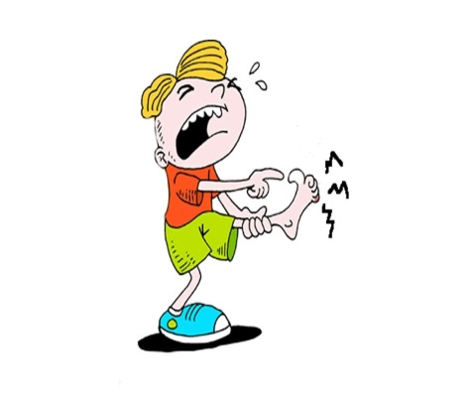****

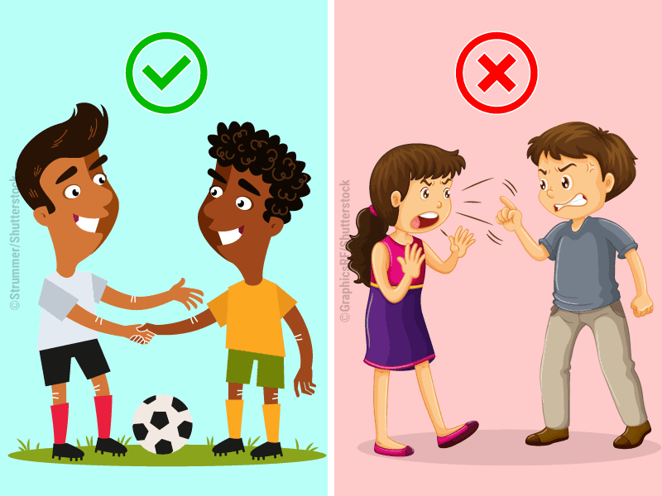



**You should know and understand your rights. You have the right to feel safe. You have the right to feel respected.**

**Have questions**?

Ask a staff for help OR talk to

Kate Bible, your Client Rights Officer

614-252-0731 Extension 1106

OR file a grievance:

**1. Write your name and the problem on your paper**

**2. Put the paper in the box**

**3. We talk about it and help**

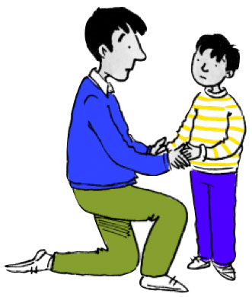



**You Can Talk To Your Doctor and Family You Can File a Grievance**